HK INSTITUTE OF VOCATIONAL EDUCATION
DEPARTMENT OF INFORMATION AND COMMUNICATIONS TECHNOLOGY

ITP4910 Software Development Project

LAB 09 – Searching a database and displaying the results

Objectives:
- To search a Database using a SQL string in a DataAdapter
- To sum and get a total in a DataTable
- To search a Database using a filter of a BindingSource
- To configure a TableAdapter using the Query Builder
- To search a Database using a FillToolStrip for a DataTable

To search for certain specific records in a database, a SQL statement with WHERE clause is commonly used by the data adapters to specify the views for filling a data table.

Part A Using a SQL statement in a DataAdapter

- Download a database ITP4910-Lab09-DB.zip.

- Create a new project of type Windows Applications. Enter Lab09 as its name. Unzip the Employee.accdb database files and place them inside the Debug directory of your application.

- In form Form1, create two textboxes, two buttons, one label and one DataGridView on it with the following properties.

Properties Table

Object | Property | Setting
Form | Name  Text | Form1  Searching a database by a DataAdapter
Button | Name  Text | btnSearch  Search by Lastname
Button | Name  Text | btnSearchName  Search by Name
Text Box | Name  Text | txtSearch
Text Box | Name  Backcolor  BorderStyle  ReadOnly  Text | txtSQL  Info  Fixed 3D  True  Your Search String is :
Label | Name  Text | lblSearch  Please enter the name and click the Search button
DataGridView | Name | dgvDisplay

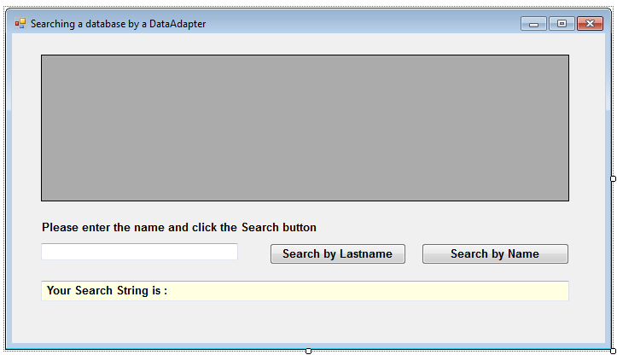

- Include the OleDb libreary.

using System.Data.OleDb;

- In the Declaration section of the Code window, declare two form variables connStr and sqlStr.

private DataTable dt = new DataTable();
private string connStr = "Provider=Microsoft.ACE.OLEDB.12.0;"
+ "Data Source=Employee.accdb";

- Add a procedure UpdateGrid

private void UpdateGrid(string sqlStr) {
txtSQL.Text = "Your Search String is : " + sqlStr;

OleDbDataAdapter dataAdapter =
new OleDbDataAdapter(sqlStr, connStr);
dt.Clear();
dataAdapter.Fill(dt);
dataAdapter.Dispose();
dgvDisplay.DataSource = dt;
}

- Use the following code in the Form Load event to fill dt with data from the database and display it in the DataGridView object dgvDisplay

private void Form1_Load(object sender, EventArgs e) {
UpdateGrid("Select * from Employees");
}

- Add code for the event btnSearch_Click.

private void btnSearch_Click(object sender, EventArgs e) {
UpdateGrid("Select * from Employees where LastName = '"
+ txtSearch.Text + "'");
}

- Run the program to see if the data can be shown correctly in the DataGridView control dgvDisplay.

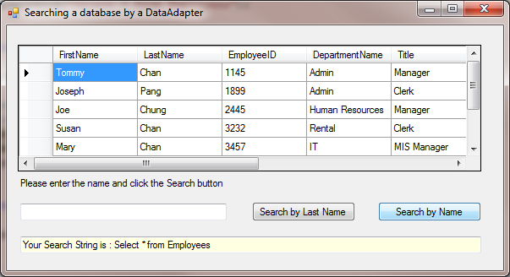

- Enter Chan in the text box. Then click on the Search by Lastname button.

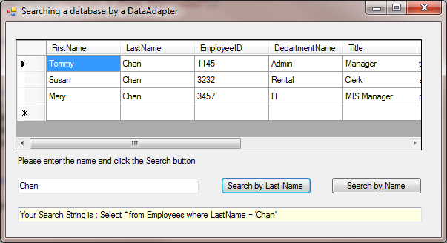

Hint : The single quote ' in the SQL statement is needed to embed the enquiry last name.

sqlStr = "Select * from Employees WHERE LastName = '" + txtSearch.Text + "'"

- Close Form1 and add code for the event btnSearchName_Click.

private void btnSearchName_Click(object sender, EventArgs e) {
UpdateGrid("Select * from Employees where LastName Like '%"
+ txtSearch.Text + "%' or FirstName Like '%"
+ txtSearch.Text + "%'");
}

- Run the program. Enter Pa in the text box. Then click on the Search by Name button. Stop the program.

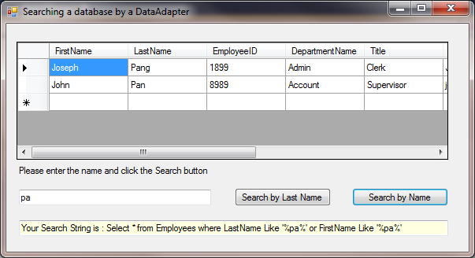

Hint: In this case, we have used LIKE, the matching patterns with % as wildcard, and the logical conjunction OR as condition in the SQL statement.

Finding total in a DataTable

- Add a label and a button on Form 1 according the following table.

Properties Table

Object | Property | Setting
Button | Name  Text | btnTotal  Find Total Salary
Label | Name  Text  Backcolor  BorderStyle | lblTotal  Total salary of the staff is :  Info  Fixed 3D

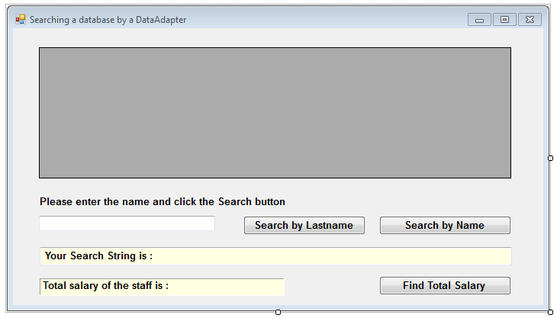

- Add code for the event btnTotal_Click.

private void btnTotal_Click(object sender, EventArgs e) {
UpdateGrid("Select * from Employees");

double total = 0;
for (int i = 0; i < dt.Rows.Count; i++)
total += Convert.ToDouble(dt.Rows[i]["Salary"].ToString());

lblTotal.Text = string.Format(
"Total salary of the staff is : {0:N}", total);
}

- Run the program and click on the button Find Total Salary.

Part B: Using a filter String in a Binding Source

Visual Studio 2010 provides BindingSource components for connection to a database. We can make use of the filter property of the BindingSource to accomplish searching tasks. When we add the filter to the BindingSource, the according DataGridView will only show those records that match with the filter condition.

- Create a new form named Form2 with text “Searching a Dataset”. When running your Form2, remember to change the start-up form of your project to Form2.

- Following the similar steps in previous laboratories, add a data source to your Form. Choose all tables and name the DataSet employeeDataSet.

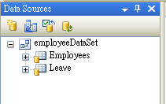

- In the Data Sources window, drag the Employees node onto the form design surface. This will add a DataGridView control of the columns of the Employees table. It will also add a EmployeesBindingSource, a EmployeesBindingNavigator, a EmployeeDataSet and a EmployeesTableAdapter to the form. Name the DataGridView control as dgvDisplay.

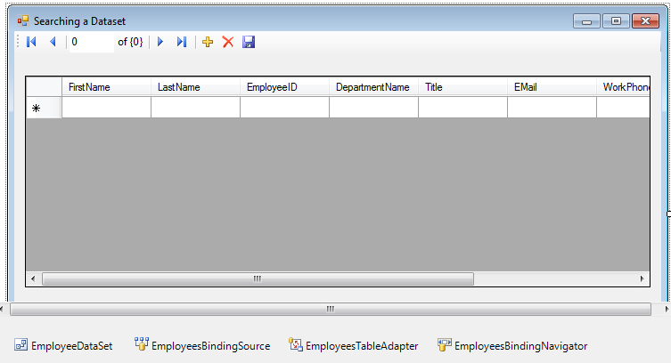
- Create two textboxes, two buttons, one label with the following properties.

Object | Property | Setting
Button | Name  Text | btnSearch  Search by Rank
Button | Name  Text | btnSearchName  Search by Name
Text Box | Name  Text | txtSearch
Text Box | Name  Backcolor  BorderStyle  ReadOnly | txtSQL  Info  Fixed 3D  True
Label | Name  Text | lblSearch  Search keyword

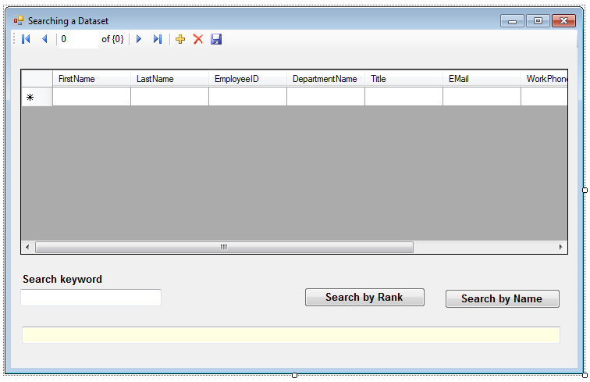

- Add code for the event btnSearch_Click.

private void btnSearch_Click(object sender, EventArgs e) {
string filterStr = "Title = '" + txtSearch.Text + "'";
employeesBindingSource.Filter = filterStr;
txtSQL.Text = "Your filter string is " + filterStr;
}

- Add code for the event btnSearchName_Click.

private void btnSearchName_Click(object sender, EventArgs e) {
string filterStr = "LastName Like '%" + txtSearch.Text
+ "%' or FirstName like '%" + txtSearch.Text + "%'";
employeesBindingSource.Filter = filterStr;
txtSQL.Text = "Your filter string is " + filterStr;
}

- Run the program. Enter Manager in the textbox and click on the Search by Rank button.

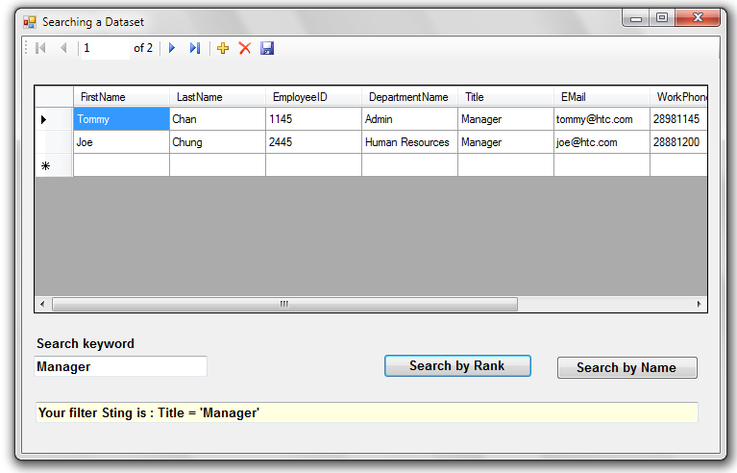

- Enter Ch in the textbox and click on the Search by Name button.

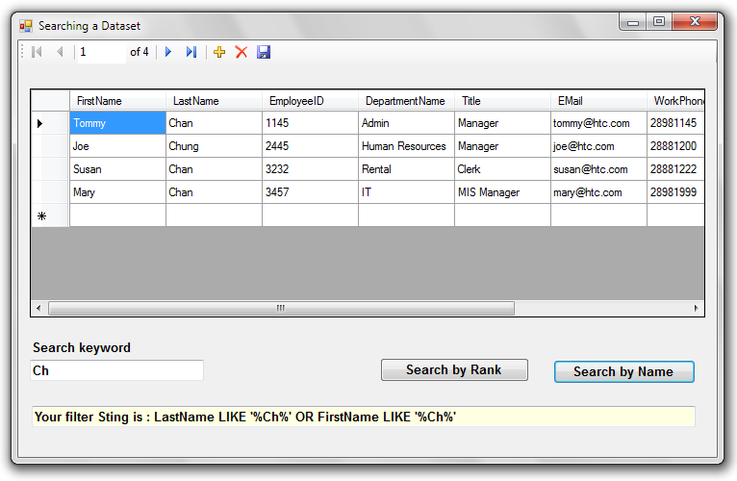
Hint :
- The condition of a C# filter is a WHERE clause in a SQL statement.

filterStr = "Title = '" + txtSearch.Text + "'";

- The keyword LIKE and the logical conjunction AND, OR can also be used in the filter as in the SQL statements in PartA

filterStr = "LastName Like '%" + txtSearch.Text
+ "%' or FirstName like '%" + txtSearch.Text + "%'";

- The single quote ' in the filter is needed as in the SQL statement before.

Part C: Using a FillToolStrip for a DataTable

TableAdapter usually fill all records to a data table. However, we can choose not to fill all records by adding a parameter in the TableAdapter.

- Create a new form named Form3 with text “Searching by a filter in a DataAdapter”. When running your Form3, remember to change the start-up form of your project to Form3.

- To add a new TableAdpater, double click the EmployeeDataset.xsd in the Solution Explorer and then right click on the blank area. Choose Add and then TableAdapter.

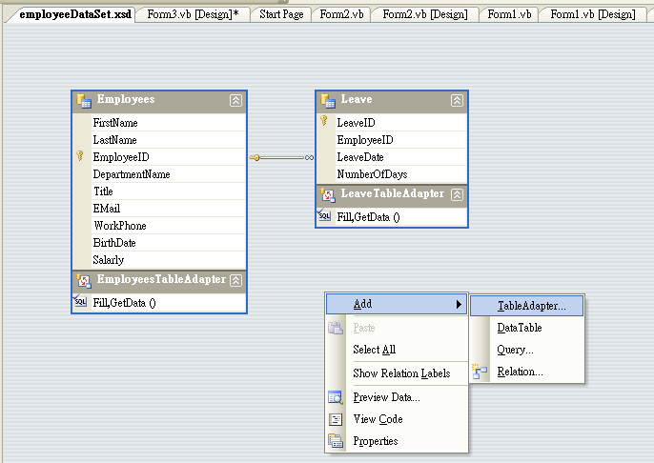

- Click Next and Choose Use SQL statements in the TableAdapter Configuration Wizard dialog and then click Next.

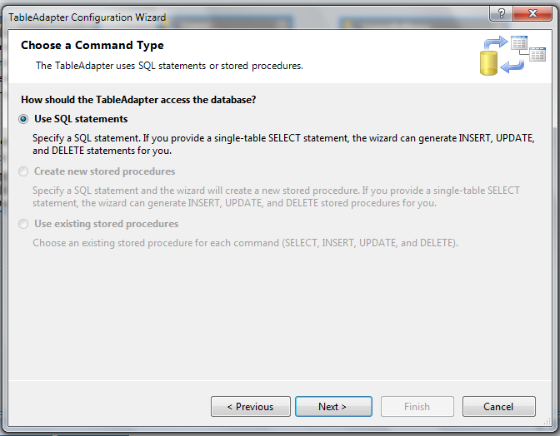

- Click the QueryBuilder button and then add the Employees table.

- Select the fields FirstName, LastName, EmployeeID, DepartmentName, Title and Salary and click OK.

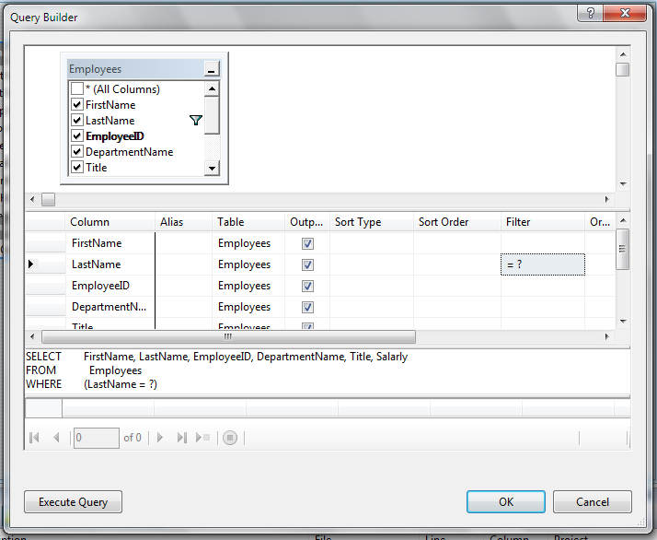

- Click Finish. Rename the new data table as EmployeesByLastname. Close and save the changes of EmployeeDataset.xsd. A new table EmployeesByLastname will appear in the Data Sources window.

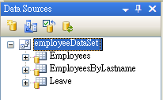
- In the Data Sources window, drag the EmployeesByLastname node onto the form design surface.

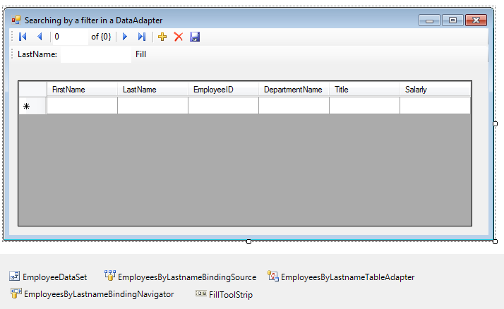

Hint :
- In addition to the DataSet, BindingSource, TableAdapter and BindingNavigator, a FillToolStrip “LastName: _______ Fill” is generated.
- If you view the code window of Form3, the following code are generated for the event FillToolStripButton_Click.

private void fillToolStripButton_Click(...) {
try {
this.employeesByLastnameTableAdapter.Fill(
this.employeeDataSet.EmployeesByLastname,
lastNameToolStripTextBox.Text);
}
catch (System.Exception ex) {
System.Windows.Forms.MessageBox.Show(ex.Message);
}
}

- We can make use of the FillToolStrip to search for some records in the database by entering the required last name.

- Run the program. Enter Chan in the FillToolStrip and click Fill.

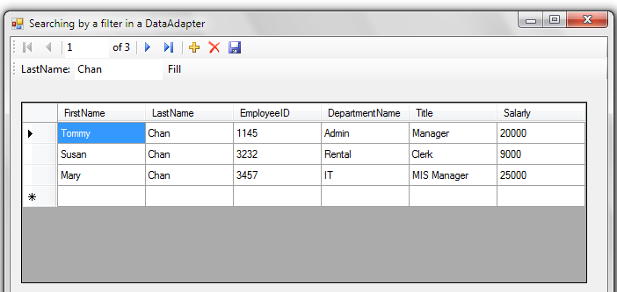
- Try other last names and close the program.

- Add a combo box with name cboName and a button with name btnSearch and text Search.

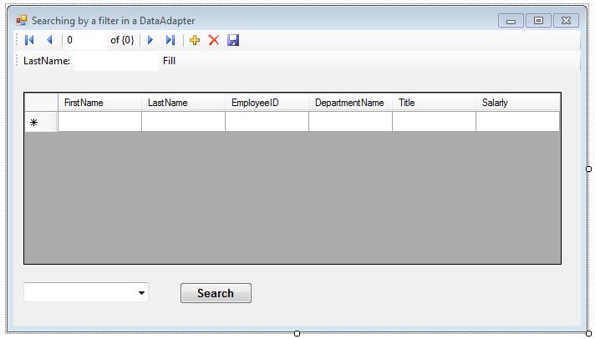

- Add the following code in the Form Load event.

private void Form3_Load(object sender, EventArgs e) {
EmployeeDataSetTableAdapters.EmployeesTableAdapter ta =
new EmployeeDataSetTableAdapters.EmployeesTableAdapter();
EmployeeDataSet.EmployeesDataTable employeesTable =
new EmployeeDataSet.EmployeesDataTable();

ta.Fill(employeesTable);
for (int i=0; i<employeesTable.Rows.Count; i++)
cboName.Items.Add(
employeesTable.Rows[i]["LastName"].ToString());
}

- Add code for the event btnSearchName_Click.

private void btnSearch_Click(object sender, EventArgs e) {
employeesByLastnameTableAdapter.Fill(
employeeDataSet.EmployeesByLastname,
cboName.SelectedItem.ToString());
}

- Run the program. Choose Chan from the ComboBox and click on the Search button.

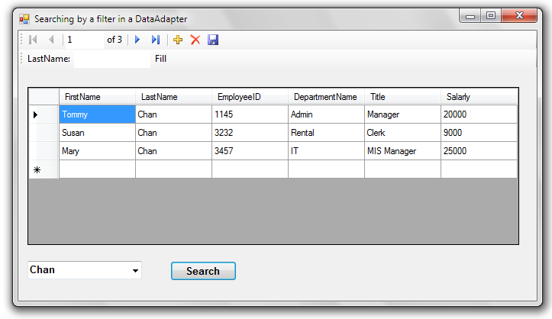

Hint : If you would like to design the form so that when a user select a name on the combo box, the matched records will be displayed automatically. You can delete the Search button and use the event cboName_SelectedIndexChanged. Try it yourself.

- Test the program by other last names. Since the values of the LastName field are not unique, you may find duplicate values on the ComboBox. Try to modify your program to eliminate duplicate values on the ComboBox.

